GUIDE FOR WORK EXPERIENCE 2026
This document is designed to help guide you to find a suitable work experience host.
This process is done in 3 stages:

Stage 1: Career Destination Planning (we have completed this stage during your connect careers program)
Stage 2: Researching Employers and Finding Hosts
Stage 3: Contacting Hosts

Stage 1: Career Destination Planning

You have been researching career pathways during your connect lessons. You will use your results from your exploration to prepare yourself for Work Experience and complete Stage 2 and Stage 3. If you want to engage in further career destination planning, a few links and potential job examples can be found below:

- A link for picking a career and job preparation suggestions: myfuture - Benefits of work experience
- QTAC Guide: A pdf document will be emailed to all parents and students – to use this guide to learn more about entry requirements for courses.

- Searching for industries and jobs:
- Seek - Career Advice and browse ‘careers-by-industry.
- https://www.yourcareer.gov.au/
- https://www.jobsandskills.gov.au/data/occupation-and-industry-profiles

Stage 2: Researching Employers & Finding Hosts

Who are some local employers you would like to work for in this field?

Remember, when researching these employers, you should be considering these are the employers you would be actively job searching with if this were 3 – 7 years from now.

Networking: It is about who you know
You should also consider your social networks as a potential source of career exploration. Many opportunities in your future careers will be found through both professional and personal contacts. This is the essence of ‘networking.’

These connections are not just about casual chats; they are about fostering networks that can shape your path forward and open opportunities you did not know were there. Do not underestimate the impact of a single conversation, it could lead to work experience, job referrals, or insights you will not find elsewhere.

Take the initiative, attend community events, connect with mentors within your circles, and do not hesitate to seek guidance. Remember, the network you build within your personal sphere today could be the key to unlocking endless possibilities tomorrow. Start cultivating these connections now, and witness how they can propel you toward your goals and aspirations.

When collating your list please collect the following information outlined on the next page.

Using Google Maps or similar websites can be an effective way to find local organisations.

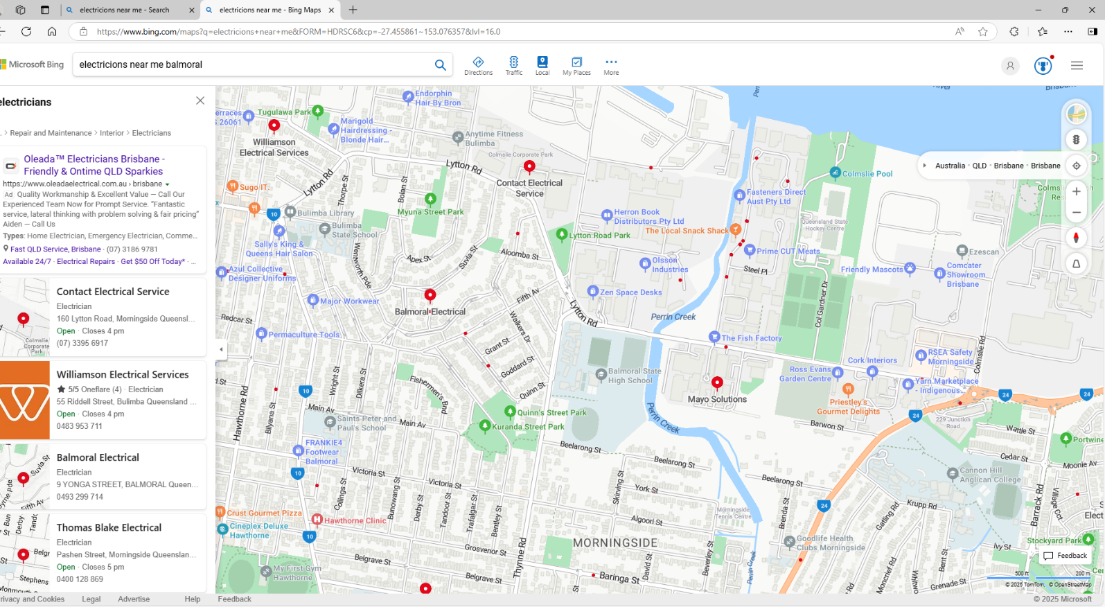

Company Name
Address
Phone Number
Why would you want to work for them?

Company Name
Address
Phone Number
Why would you want to work for them?

Company Name
Address
Phone Number
Why would you want to work for them?

Stage 3: Contacting Hosts

When making the first contact with an employer, it can make students feel anxious. This can be done over the phone or in person. Some students may receive help from having a script to help them structure the conversation. If you are calling/visiting a potential host for the first time, they will not be expecting you. This is called a ‘cold-call.’ They understand you might be nervous about making this contact.

Important Consideration: Game of Numbers
When cold-calling potential employers for work experience, you can expect that not every host you contact will be able to say ‘yes.’ If they tell you that they are unable to take you on do not take this to heart.

- Rejection can feel disheartening, but it is essential to approach it as a learning opportunity rather than a setback. Remember that rejection is not personal; it is often about timing or the host’s capacity. Keep a positive mindset and understand this should be considered a game of numbers. Each ‘no’ will lead you closer to the host who will say ‘yes.’ The more calls you make, the higher your chances of finding a host.

- The more you do it, the more confident you will become with calling hosts. Be resilient and persistent; success often comes after multiple attempts. After a rejection, reflect on how the call went and use it to improve your approach for the next call. Keep track of your progress and celebrate small victories along the way.

- Many hosts will give a non-committal answer, asking if you can send some more information. Record their email and contact details and the school will provide them with more information. Be sure to mention to the school that this was a ‘request for Information’ and not a ‘confirmation.’

Before the call:
Be prepared before you make the call by knowing what to expect and having your information ready.

- Make sure you know the name and number of the organisation.

- What information you need from them?
  - Who is the correct person to talk to?
  - Whether they would be interested in hosting you.
  - The organisations contact details.

- You know your own availability to discuss when you would like to complete the placement.

- Have a pen and paper ready to take notes.
When you call them, you may not get the person you need to speak with immediately. Be sure to confirm who you are speaking with and to print their name.

The Script

- Introduction:

“Hello, my name is [_____________] and I am a student at Balmoral State High School. Would I be able to have a quick chat with someone there about potential work experience?”

- Reason for call:

“Balmoral State High School allows students to participate in the Work Experience Program between 22nd and 26th June 2026, which is the last week of Term 2. This program gives students like me experience in a profession we wish to eventually work in. We are asked to consider which companies and organisations we would like to work for if we were qualified today. I am calling today because I wish to become a [___________] and would love the opportunity to experience what a week in the life would be like at your company.”

- Call to action:

“If you may be interested, I can pass your contact details onto my school, and they can send you through some more information and discuss the details.”

- Record:
Time: Date:
Contact Name: Company Name:
Email: Phone number:
- Conclude:

“Thank you for taking the time to speak with me today. I look forward to the opportunity to experience working for you in this industry. A staff member from Balmoral State High School will be in contact with you shortly with more details.”

Ensure to complete Stage 2 and Stage 3 of this guide.
Upon completion of this guide and after you have secured your placement, please fill out this page and return this page only via email to Ms. Sof – tsofr1@eq.edu.au
Once we have received your work experience host details below, we will then be able to start the formalised work experience documentation and process for you to secure your placement in Week 10 in Term 2.
My work experience host details completed below.
Student Name & Signature:
I agree to my personal details being released to employers for the purpose of work placement allocation.

Host Company Name:

Host Company Address:

Contact Name:

Job Title:

Contact Number:

Contact Email:

Parent/Carer Approval:  I give permission for my student to participate in work experience in Week 10 of Term 2 and will support travel to and from the workplace each day. | Parent/Carer Name:
Date: | Parent/Carer Signature:

